setting up node-red in raspberry pi
- use raspberry pi imager
- setup raspberry pi with node-red
- node-red
- network settings
- current task (please refer)

*take out the sd card from the raspberry pi on the rack to reformat it.
The SD card is found at the bottom of the raspberry pi btw, if you don’t know just look at another one and you will get it
- use raspberry pi imager
- go to https://www.raspberrypi.com/software/ and download the imager.
- select
  - choose device: raspberry pi 3
  - choose os: go other, then select raspberry pi os lite (64-bit)
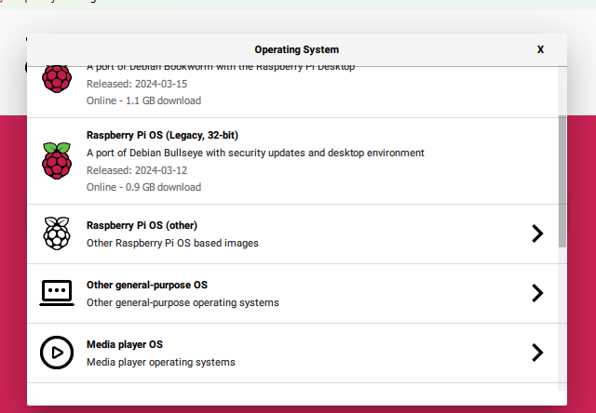
  - choose storage: the sd-card that you have inserted into your pc from the raspberry pis and click next
  - click on edit settings
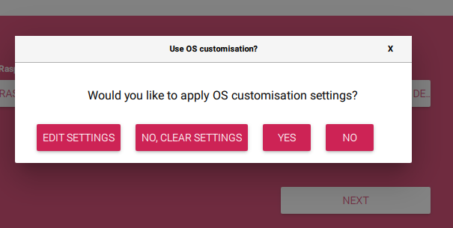
  - follow the below settings
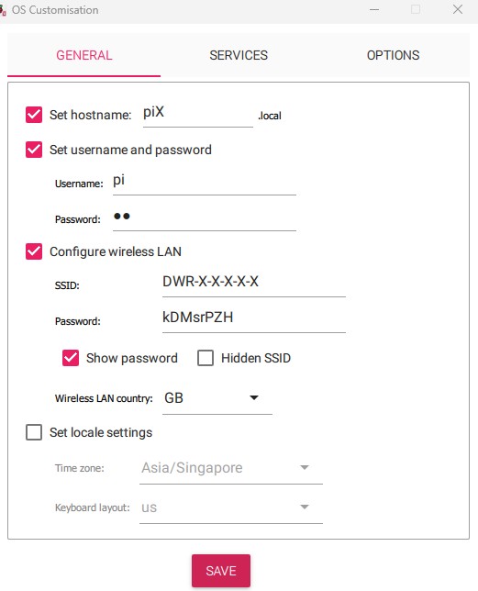
  - set hostname: pix (x is the pi number, if its for pi7, hostname is pi7)
  - username: pi
  - password: pi
  - ssid: DWR-921-C3CD
  - password for router: kDMsrPZH
  - then go to services
    - enable ssh
      - select “use password authentication” and save
- click “yes” to confirm edits
- wait for it to finish writing.

- setup raspberry pi with node-red
- once writing is finished, put back the sd-card into the raspberry pi (switch it off and on) and plug in the hdmi and keyboard into the raspberry pi
To switch it off and on, find the white plug connected to the power source and turn it off and on)
  - at this point, you can also ssh into the raspberry pi if you prefer (only ssh once the raspberry pi is on wlan0)
  - check if there is a wlan0 ip address and take note of it for creating the topology
- type in the commands
  - sudo apt update
  - sudo apt upgrade (to save time, i think can don’t use this command)
- install node-red
  - type: bash <(curl -sl https://raw.githubusercontent.com/node-red/linux-installers/master/deb/update-nodejs-and-nodered)
    - will have some confirmation that needs user input (just put yes for both if you see any)
  - start node-red by typing: node-red-start
  - if you want node-red to start automatically when your raspberry pi boots, you can enable the service by running: sudo systemctl enable nodered.service
- in your command line (at default home directory: /home/pi), type:
  - mkdir ied
  - sudo touch /home/pi/ied/sv_ied.txt
  - sudo touch /home/pi/ied/goose_cb_ied.txt
  - sudo chmod -R 777 /home/pi/ied
- node-red
- once node-red is running go to http://<ip-address of the raspberry pi>:1880
- click on the hamburger menu on the top right, click on “import” and then click on “select a file to import”
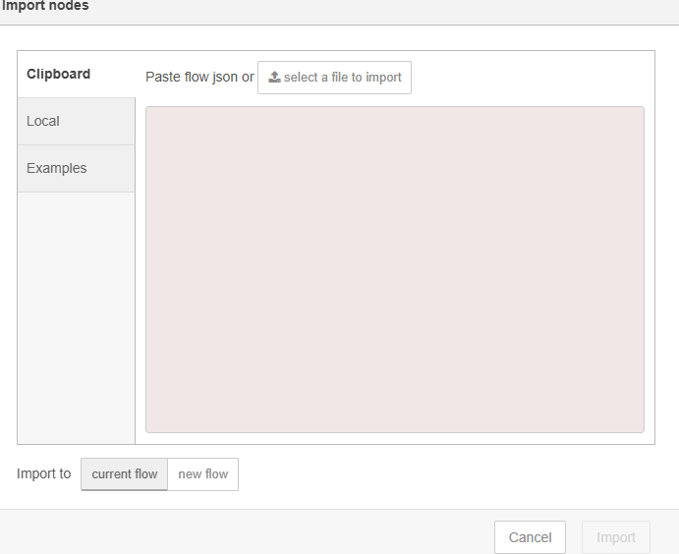
- select the json file that was given and click “import”
- after that, go to the hamburger menu on the top right again, click on “manage palette”
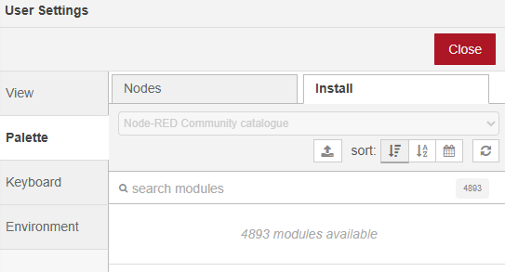
- at the install tab, search and install the following nodes:
- node-red-contrib-ui-led
- node-red-contrib-modbus
- node-red-dashboard
- node-red-node-sqlite
- node-red-node-ui-table
- once all is done, click on “deploy” next to the hamburger menu and confirm deployment

- network settings
- go back to your cli, then type: sudo nano /etc/network/interfaces
- enter the following.
auto eth0
iface eth0 inet static
address 192.168.1.x (if this is pi7, it is 192.168.1.8 (7 + 1)
netmask 255.255.255.0
gateway 192.168.1.1
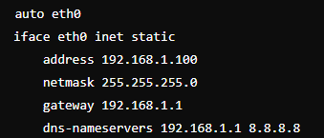
- once down, save then type the command: sudo systemctl restart networking
- then, run;
  - sudo ip route add default via 192.168.0.1 dev wlan0 metric 100
  - sudo ip route add default via 192.168.1.1 dev eth0 metric 200
  - sudo ip route del default via 192.168.1.1 dev eth0
(This whole section is optional, just make sure the raspberry pi connects to the internet wlan0 needs to be up)

- current task (please refer)

current rack topo (do not touch first coloum in red)
pi1 | pi7  192.168.0.8  Eth0: b8:27:eb:c2:49:ab  Wlan:  b8:27:eb:97:1c:fe | pi13  192.168.0.14  Eth0: b8:27:eb:39:8f:08  Wlan:  b8:27:eb:6c:da:5d | pi19  192.168.0.20  eth0: b8:27:eb:13:da:b1  Wlan: b8:27:eb:46:8f:e4
pi2 | pi8  192.168.0.9  Eth0: b8:27:eb:25:6e:58  Wlan:  b8:27:eb:70:3b:0d | pi14  192.168.0.15  Eth0:  b8:27:eb:12:23:64  wlan:  b8:27:eb:47:76:31 | pi20  192.168.0.21  Eth0  b8:27:eb:00:55:b5  Wlan:  b8:27:eb:55:00:e0
pi3 | pi9  192.168.0.10  Eth0:  b8:27:eb:a6:d6:37  wlan0:  b8:27:eb:f3:83:62 | pi15  192.168.0.16  Eth0:  b8:27:eb:9a:66:cb  Wlan: b8:27:eb:cf:33:9e | pi21
pi4 | pi10  192.168.0.11  eth0:  b8:27:eb:a8:4e:9b  wlan: b8:27:eb:fd:1b:ce | pi16  192.168.0.17  Eth0:  b8:27:eb:90:22:3b  Wlan: b8:27:eb:c5:77:6e | pi22
pi5 | pi11  192.168.0.12  Eth0: b8:27:eb:22:49:61  Wlan:  b8:27:eb:77:1c:34 | pi17  192.168.0.18  Eth:  b8:27:eb:61:6c:db  wlan:  b8:27:eb:34:39:8e | pi23
pi6 | pi12  192.168.0.13  Eth0:  dc:a6:32:cc:44:be  Wlan:  dc:a6:32:cc:44:c0 | pi18  192.168.0.19  Eth0  dc:a6:32:d8:7a:b6  Wlan:  dc:a6:32:d8:7a:b7 | pi24
there is still the dhcp reservation of assigning ip addresses for wlan0 for all raspberry pis (to be done)
on wlan: 192.168.0.x (where x is the pi number +1)
on eth0: 192.168.1.x (where x is the pi number +1)
Extra if Scada fails:
Install the pymodbus server with this command
sudo apt install python3-pymodbus -y
sudo nano pymodbus_server.py
(to copy the contents pymodbus_server.py to it)
nohup python3 pymodbus_server.py > pymodbus.log 2>&1 &

